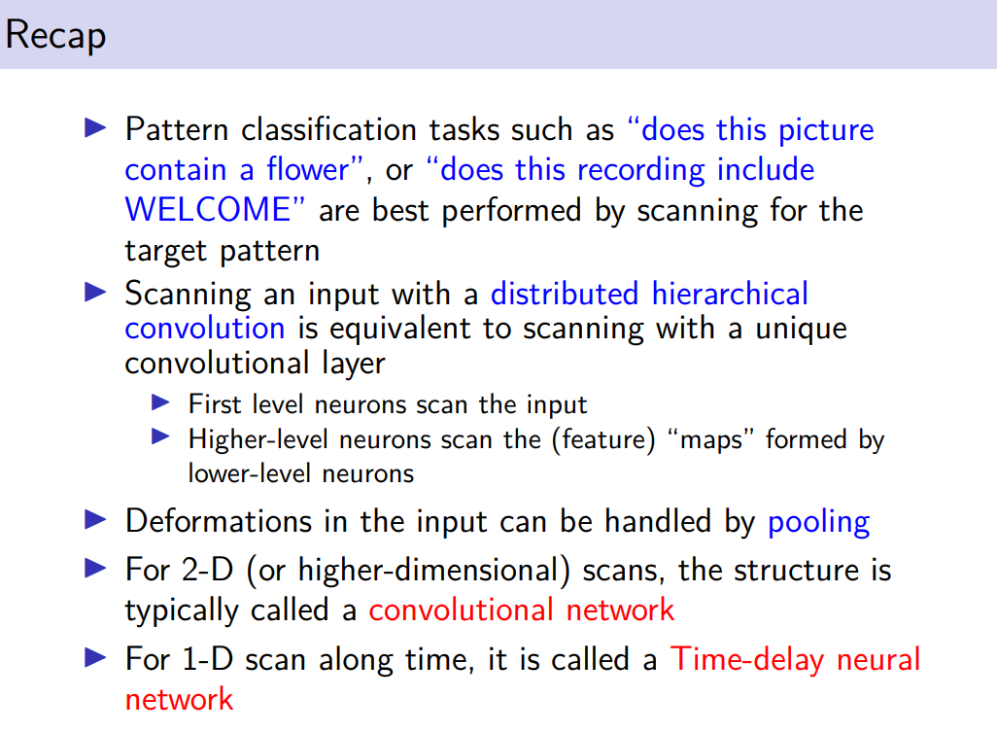

not suitable to use a deep network made by fully connected layers.
We need a different type of neurons, scan a part of the image/recording

it operatres a convolution using different confivokution layers, neurons in hier layer.
It is a jerachiky of feature extracting

advatnanges in computations and numbers of parameters.

pooling: ur model is invariant in small input variation. Can be seen as feature selection reather then feature extraction.

When we have 2D scan it is called a CNN

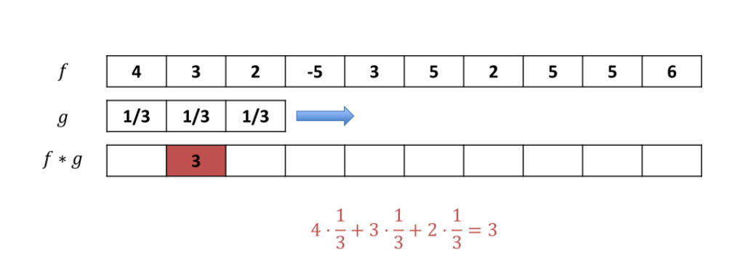
convolution in a discrete set. In CNN we talkm about discrete time.

Convolution always involve two function
The first function is the input signal

second function is the filter. we use filter of size 3. We have operate a slidiging to produce the output.

We scan an input and we produce a feature map as outcome. It will be used by layers next

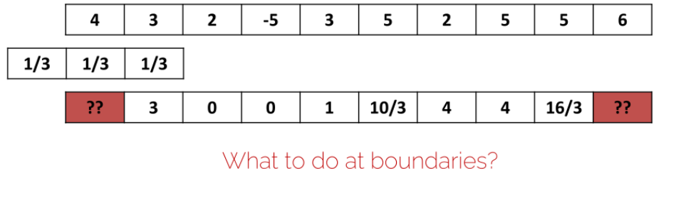
there are two values empty at the beginning. It is ok but we might loose information. If it is an image in the corner we might not have nothing so it is ok

But is better notto lose information

solution 0-batting

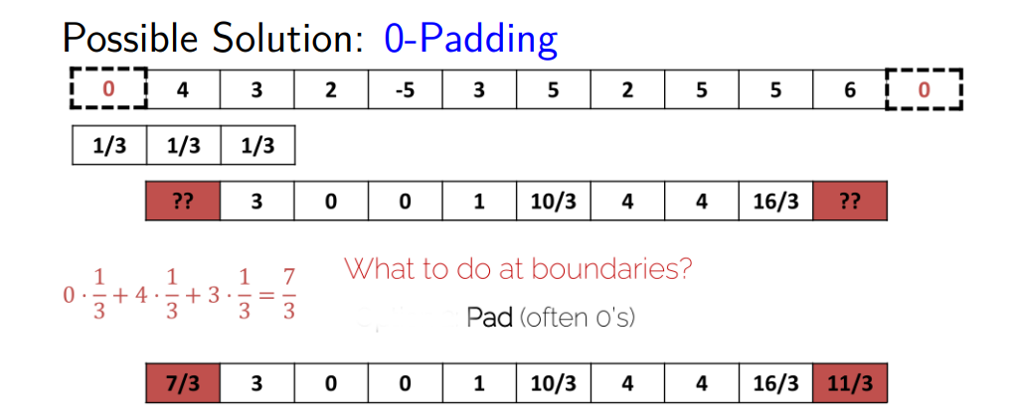

add 0 at the end and the beginning to get the same dimensjion (get feature map of same dimension of input)

to do we potentially avoid to lose information.

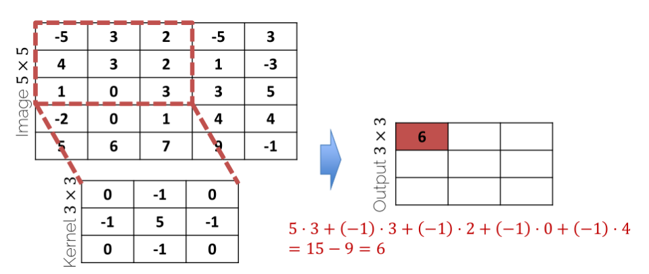
our scanning is a matrix (kernel 3x3) are the weights.
Multiply each element by the correspofing weight and sum them up

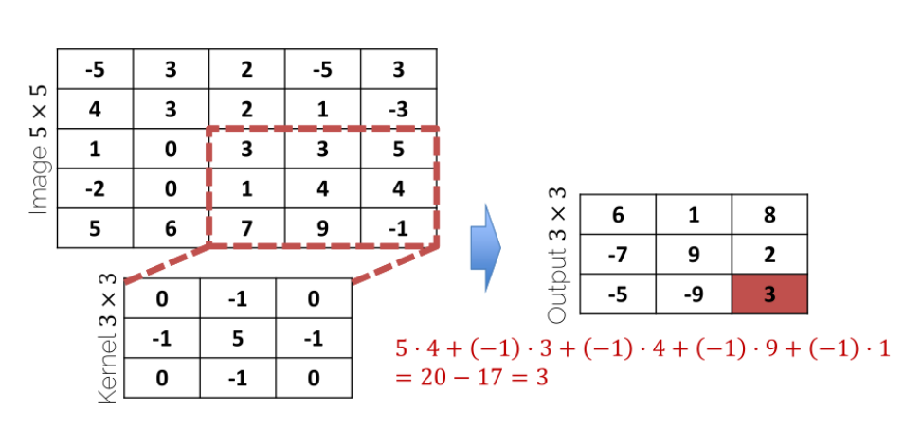

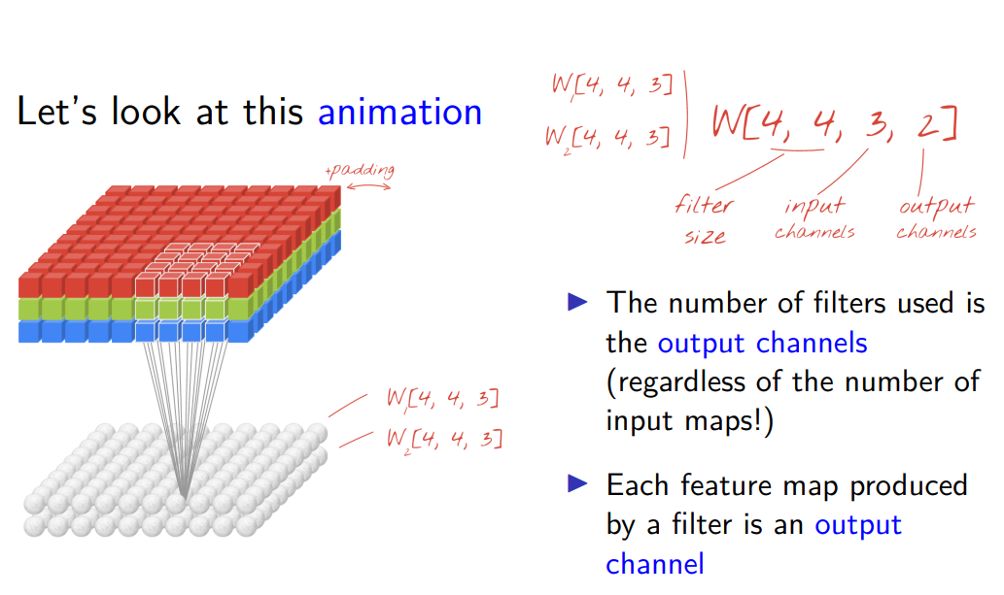
colour filter with three colour

2 is the number of output chnnles: channels will be simply input or output matrices.
1 output channel:

the dimension of the output channel is the number of output filters

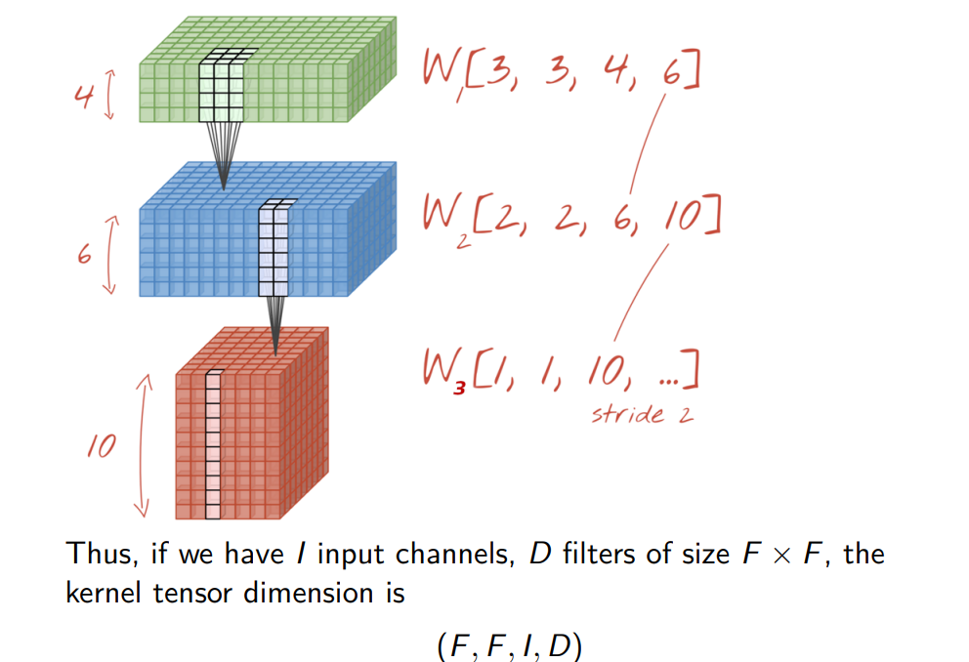
+compl

6 filters extract 6 fearrues
blue: 2x2xnumber of input channel (6)

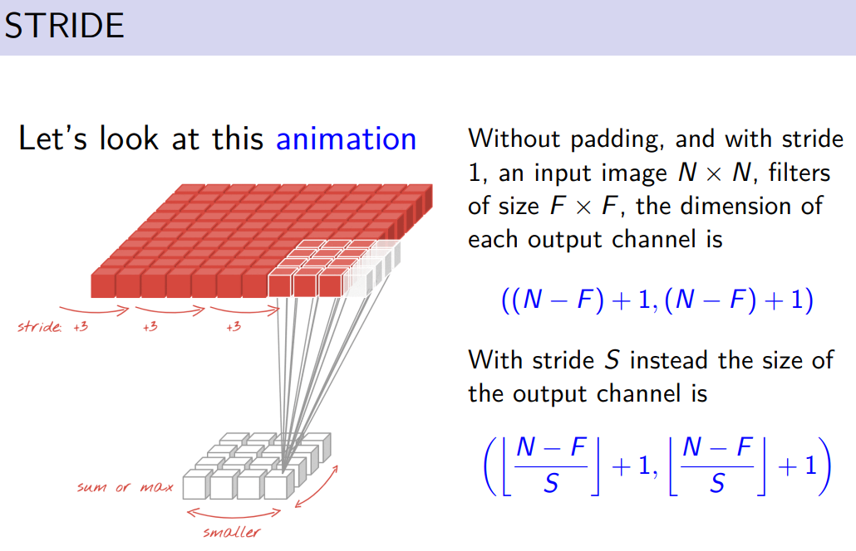
animanition changes

input channel of nxn. The dimension of output channel is N-F+1 in eahc dimension

if we use a stride S the size of output channel is (N-F)/S + 1

you can know in advance the output size

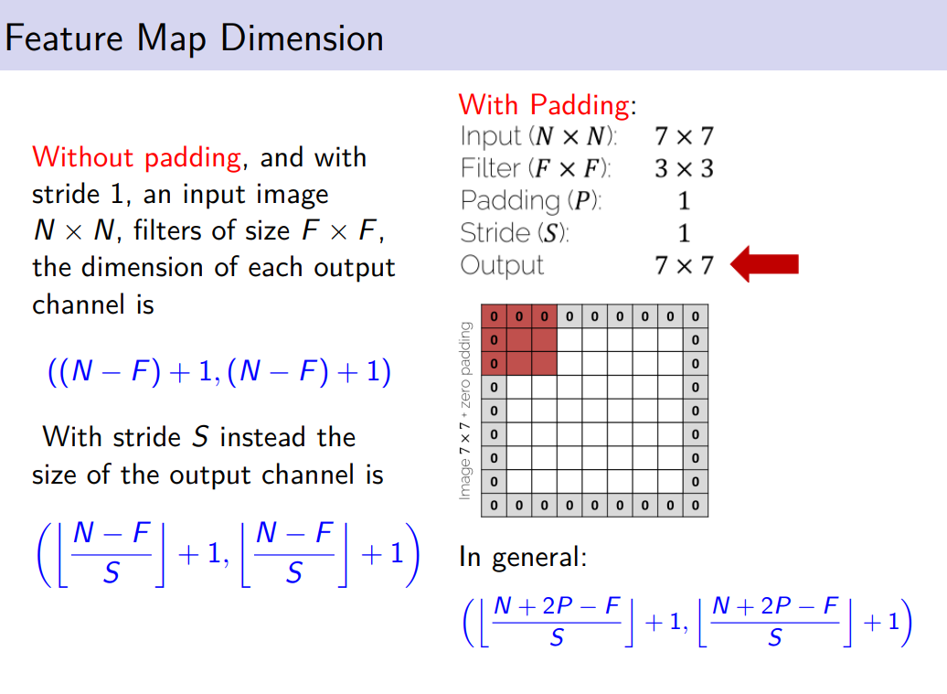

our input image is 7x7

a feature of dimewnsion 3x3
padding 1
stride 1
we get same dimension

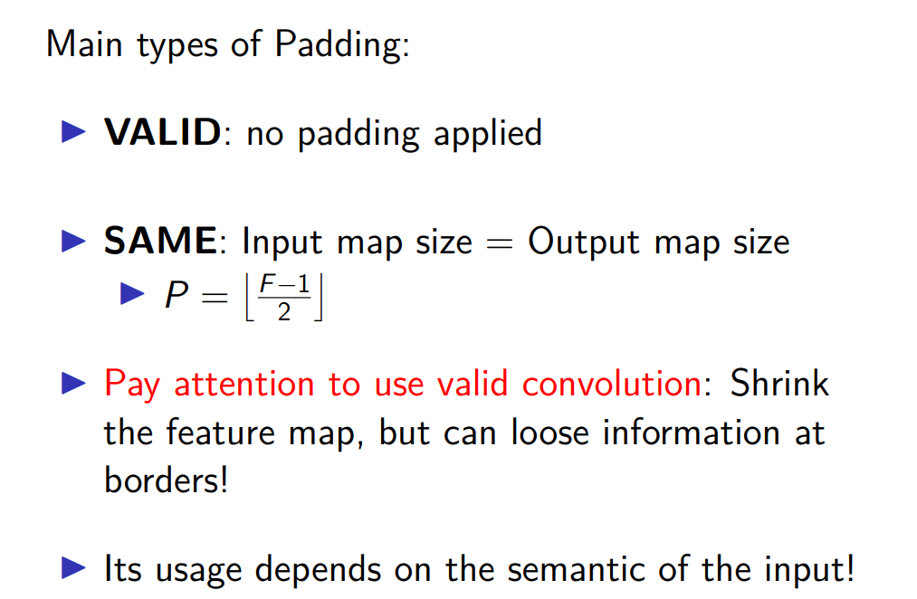
valid: no apply padding, not use 0. You get in general a feature map with smaller dimension

Same: the output size will have exactly same size of input channel

can be done by cofngiruing P

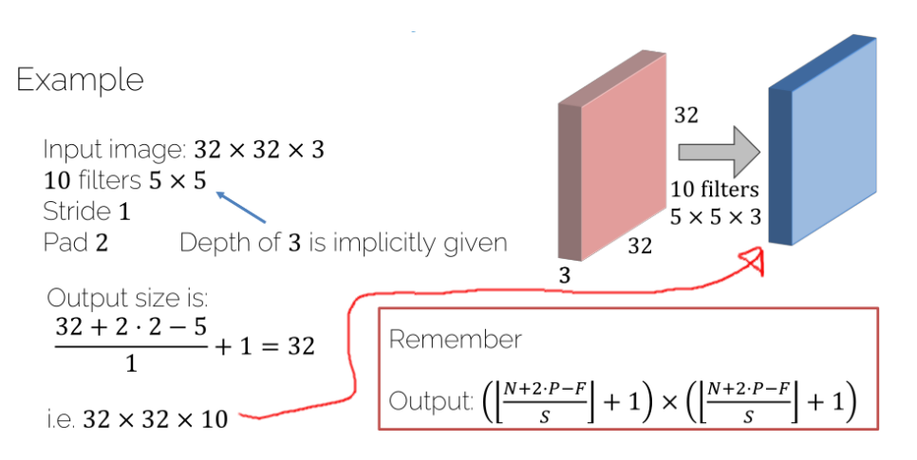

32x32x3

in 3 differen channels (red, green, blue)

we use a filter of size 5 (5x5)
the shappe of our tensor is 5x5x3

we ket same size of input

+the dimension of the output channgewl

would be 32x32x10 (10 is number of filters)



F = 4
S = 1
3 different channel
P = 0

3 + 2x0 - 5/1 + 1

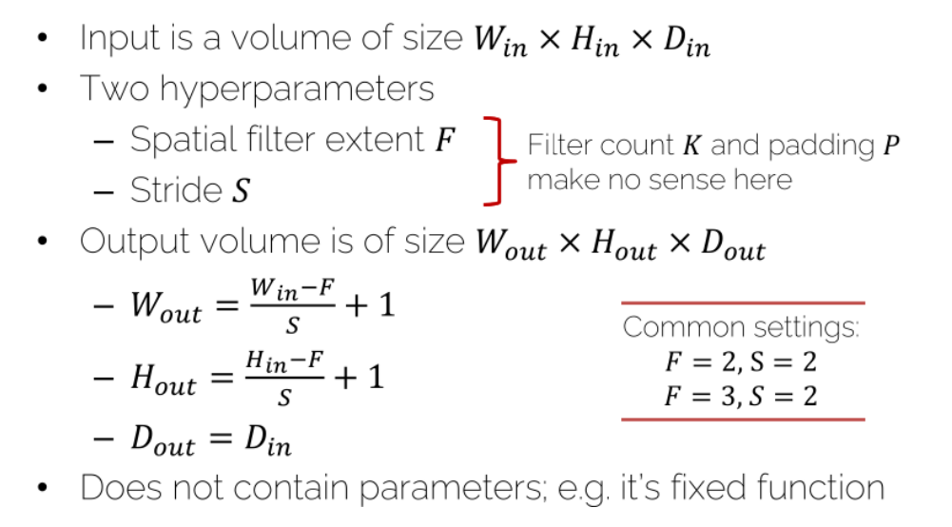

the dimension of output is the same of input, can change tiw wight and high.

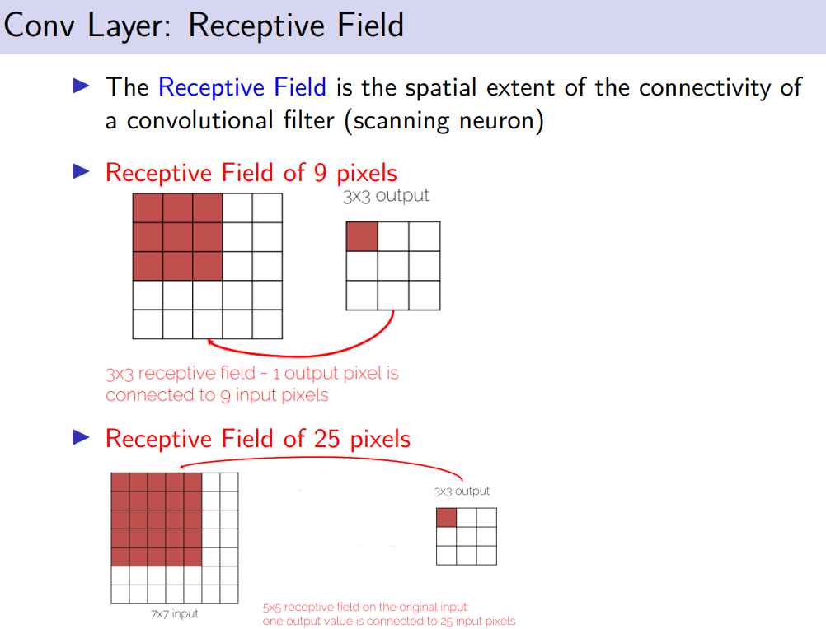

same example of before
32x32 as input channel but we have 3 input

how many parameters? the paramters are the base + 1 bias for each filter

filter 3 dimensional filter. It has 3 channels, ence 25+25+25 = 75 weights

we have 76 patamters for each filter

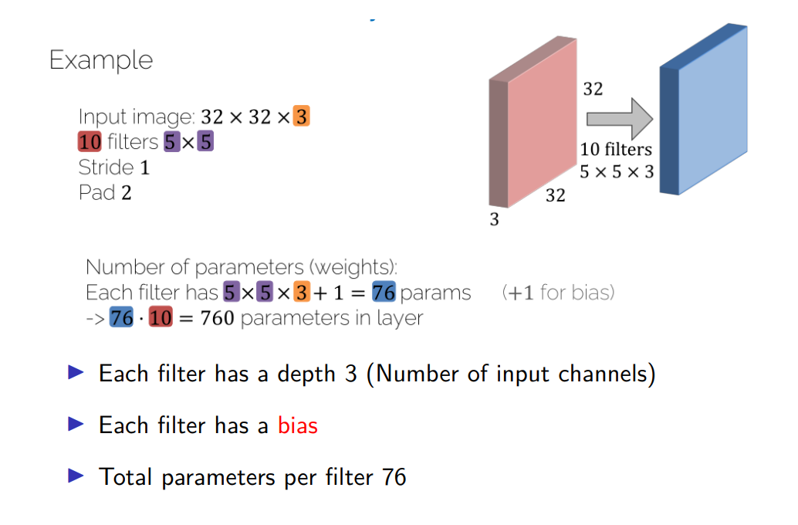

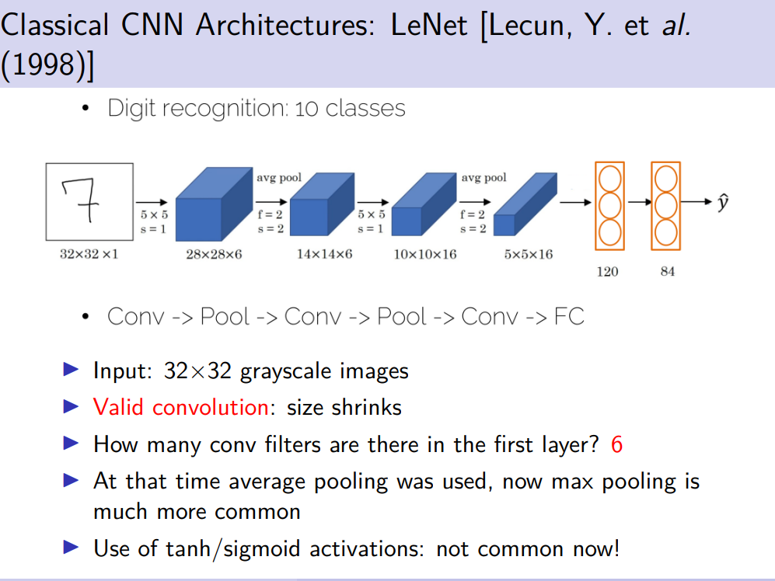
LeNet proposed too recognise handwritten digits
32x32x1

from 32x32x1 we get 28x28x6 valid convolution

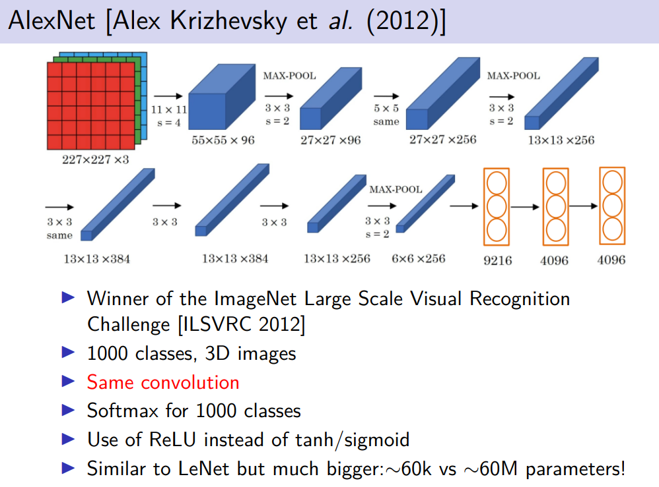
hige number of images
with 3 different channels.

in most convolutional neurneal network most parameters areoin fully connected parts

how to compress a convultuional neural network.

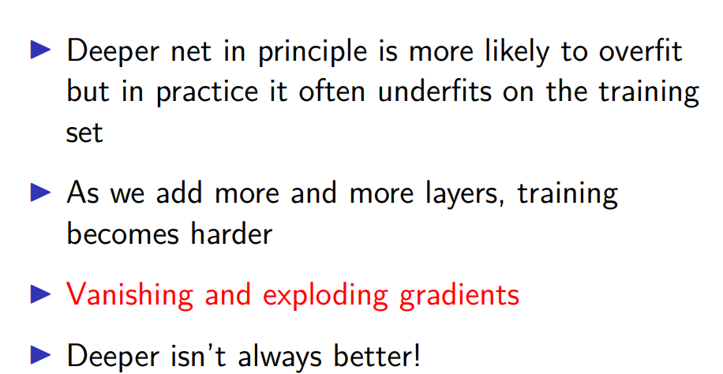
using deeper network leads to underfitting.

In the training procedure with the back propagation

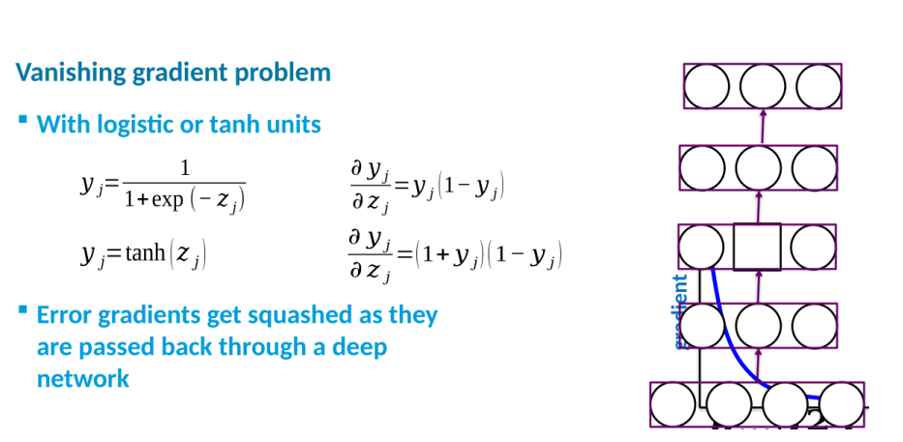
deep network when you reach the outcome you compute +compl

you compute the graditiens

have a multiplicated effect, when we have composite function+compl

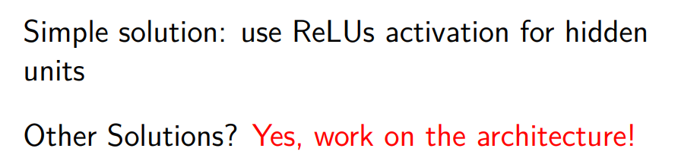

possible solution: use activation function that does not have that +compl

reLu does not have this problem

or we can work on the architecture

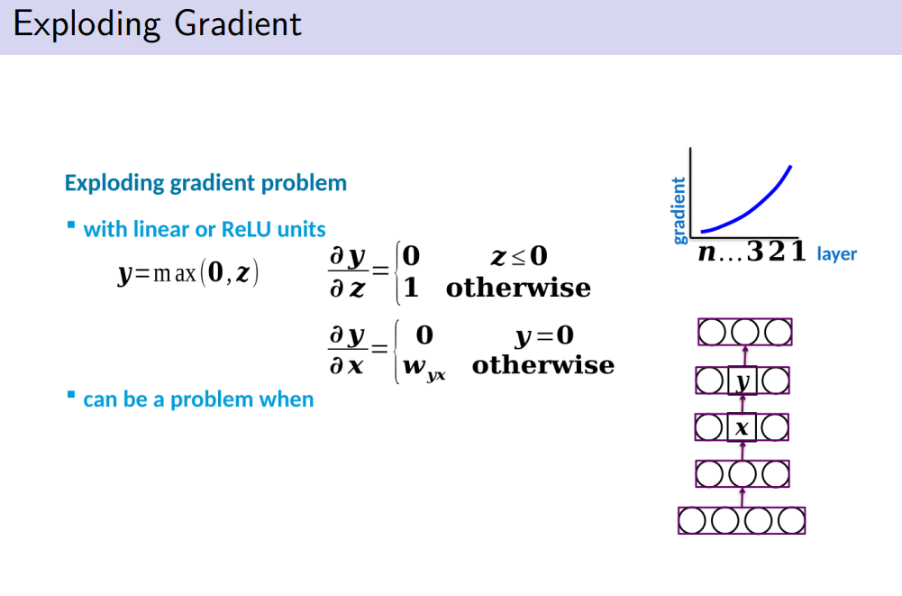

use some activation function that has detriveacts tha get larger and large

the mopre you go down the more the bradient can exploide

we need to reduce the learning rate

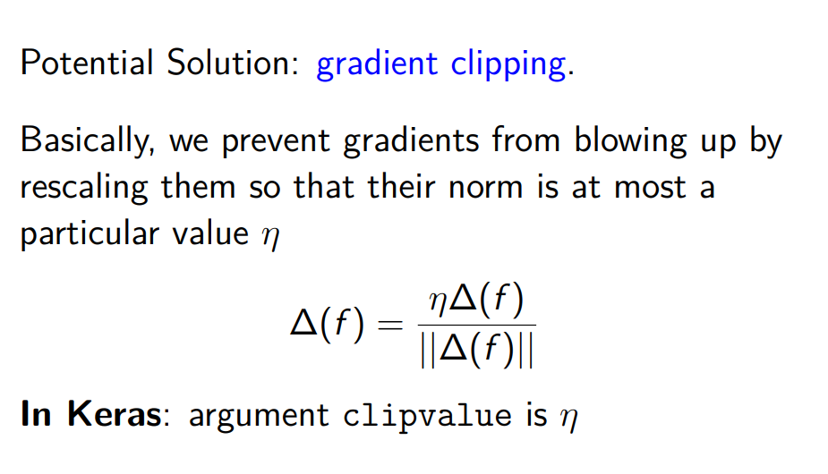
gradient clipping: just normalize it, you want you gradient with a norm equal to η
prevent your gradient frome xploding
or as solution works on the acrchitecturer

